|  |  |
| --- | --- |
|  |  |
|  | |  | | --- | | **Online Admission system** | |  | |

**ABASYN UNIVERSITY ISLAMABAD CAMPUS**

Project Report On

Online Admission System

For the course

SOFTWARE DESIGN AND ARCHITECTURE

Submitted by

Zobia Khalid Malik

Roll:3355

4th semester of BSSE

Guided by: Ma’am Madiha Naveen

Submitted to

Ma’am Madiha Naveen for the Academic year of spring 2020

**Introduction:**

The objective of the Online Admission System is to provide a system which handles the records and information related to admission, wheater new or old admssions, accepted and rejected all admissions into the admission system and maintaining their admission records. It takes care of all their details, documents, degree choosed, challans, their departmental information. Data will be stored into database.

**Modules in Online Admission System**

* Registration for Admission.
* Admission details, criteria, curriculum and prospectus.
* Adding new Admissions into the system.
* Adding new details about admission into the system.
* Adding Dcouments into system.
* Adding created Challan and payed Challan into the system
* Searching user by id in the system
* View all admission forms by id in the system.
* Storing, updating and Deleting the information about both accepeted and rejected admission, scholorships percentage and topers details.

**Usecase Diagram:**



**Fully dress Usecase Diagram:**

|  |  |
| --- | --- |
| Usecases | Description |
| Registration | Allows users to Register for system, has one to many relationship. All kind of actors the comes to system can register for account. |
| Authentication | Allows user to login and check if the username/password is correct or not. One to many relationship. All registered user will interact to authentication usecase, it will check if the login is either valid or not. |
| Documents | Allows students to upload their documents in some specific format e.g. in pdf or picture etc.  The Admission office and Student Affairs can View and Download the Documents. One to many relationship, student and admission office and student affairs will interact with documents. |
| Scholarship | The check in will be applied on the system. It is a constrain, that student with 70% or more than 70% will get scholarship automatically. Has one to many relationship. Student will get scholarship. Admission office will decide and the student affairs will create challan according to scholarship percentage. |
| Entry Test | Entry Test Letter with description of test date, place and time written on it will be sent to the deserving students by admission office. One to many relationship. The Admission office will send the letter and students can view entry test letter. |
| Test Result | After test conduction, the result of the test will be uploaded on the system. Has one to many relationships. The admission office will upload the test results, student can view the result list. |
| Admission Letter | After selection of the deserving students on the basis of the entry test result the automatic admission letter will be sent to the student by admission office. |
| Challan | One to many relationships. Finance office will upload the challan according to applied degree. The student can view the challan; download the challan, after the payment can upload the paid challan on the system. |

**Domain Model of Online Admission System:**

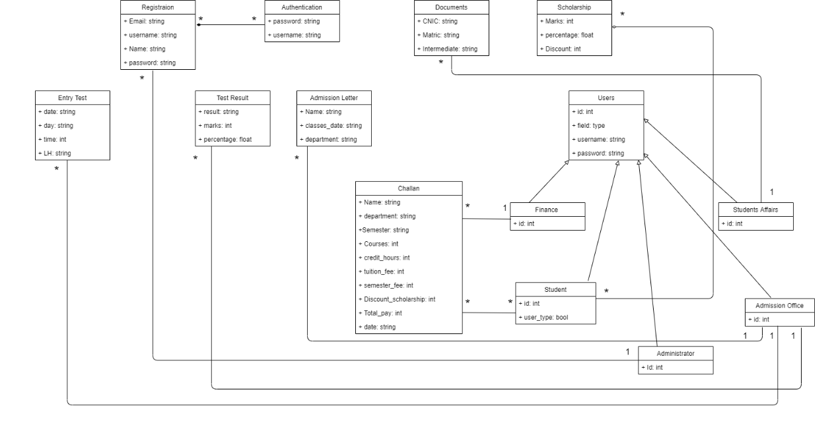

**Sequence diagram :**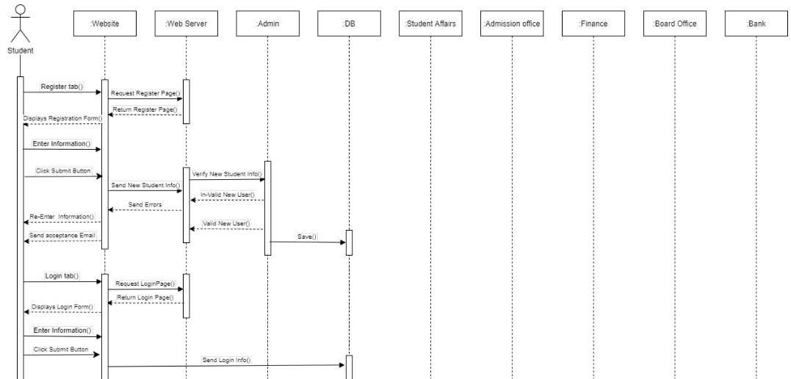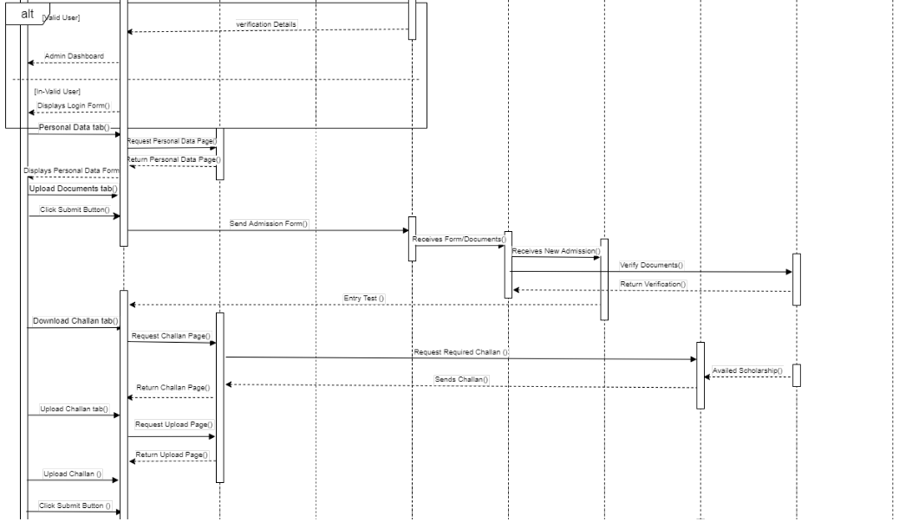 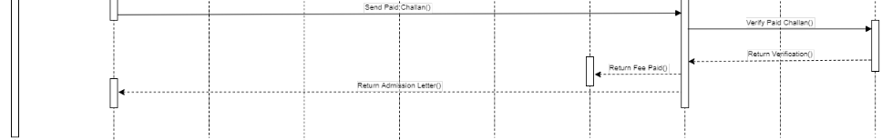

**Communication diagram:**

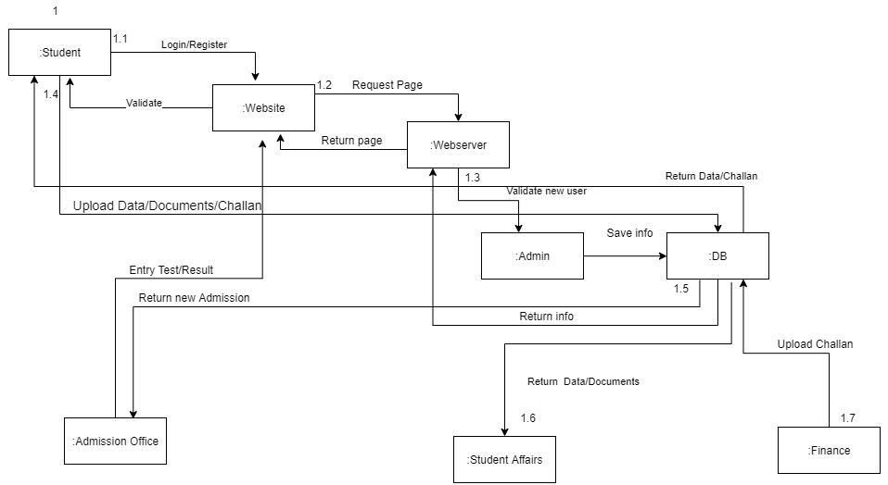

**Class Diagram of Online Admission System:**

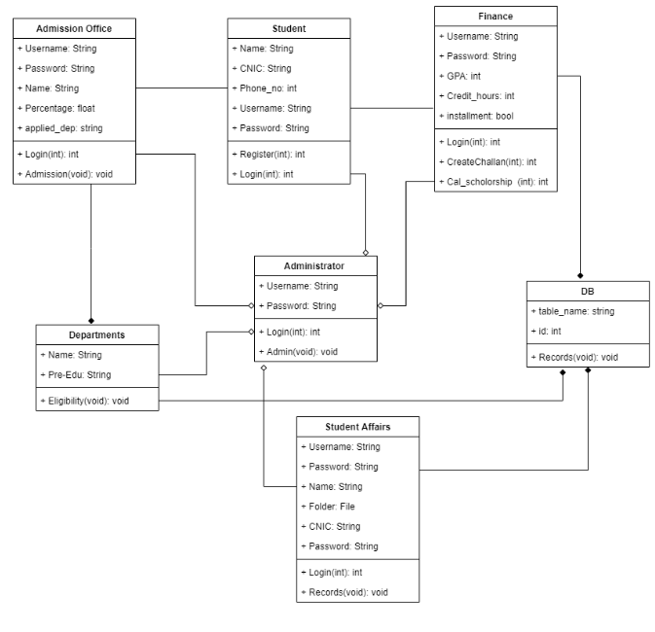

**Implementation in c++:**

**Code:**

#include<iostream>

#include<stdio.h>

#include<string.h>

#include<stdlib.h>

#include<conio.h>

using namespace std;

// structure for storing data of the enrolling student

struct admi {

int uniq_id;

char Name[50];

char dob[50];

char Gender[50];

char Religion[50];

char Nationality[50];

char Address[100];

char City[50];

char State[50];

char Father_Name[50];

char Father_Occupation[50];

char Mother_Name[50];

char Mother_Occupation[50];

char father_income[50];

char mother_income[50];

char Name_b[50];

char Name_school[50];

char school_s[50];

char maxmarks[50];

char marksob[50];

char perc[50];

char yop[50];

char Name_b1[50];

char Name_school1[50];

char school_s1[50];

char maxmarks1[50];

char marksob1[50];

float perc1;

char yop1[50];

char mig[50];

char tc[50];

char branch[50];

}form;

// structure for storing the administrator id

struct adminitrator {

float id;

}host;

// file pointers

FILE *student_detail;

FILE *admin_id;

FILE *student_id;

class Administator{

public:

int choice,op;

int feec,bec;

public:

Administator(){

choice=0;

op=0;

feec=0;

bec=0;

}

public:

int show_academic_details(){

cout<<"\n\nAcademic Details\n\n\n";

cout<<"Please Select Your Branch\n\n";

cout<<"1.Department of Computing \n";

cout<<"2.Department of Electrical Engineering\n";

cout<<"3.Department of Management & Social Sciences \n";

cout<<"4.Department of Civil Engineering\n";

cout<<"5.Department of Pharmacy\n";

cout<<"6.Department of Life Scienecs\n";

cout<<"7.Department of Rehabilitation and Health Sciences\n";

cout<<"8.Department of Technology\n";

cout<<"9.Department of Electronics\n";

cout<<"10.BS in Mathematics\n";

cout<<"\nPlease Enter your Choice \n";

cin>>choice;

switch(choice){

case 1:cout<<"\t\tDetails for the First Semester\n\n\n";

cout<<"\t\t\tPHY CYCLE\n\n";

cout<<"\tS.No.\tSubject Name\t\t\t\t\tSubject Credits\n";

cout<<"\t1\tIntroduction to Computing \t\t\t\t3+0\n";

cout<<"\t2\tIntroduction to Computer Programming \t\t\t3+1\n";

cout<<"\t3\tApplied Physics \t\t\t\t\t2+1\n";

cout<<"\t4\tEnglish-I (Comprehension)\t\t\t\t3+0\n";

cout<<"\t5\tIslamic Studies/Ethics (for Non-Muslims)\t\t2+0\n";

cout<<"\t6\tCalculus-I\t\t\t\t\t\t3+0\n";

cout<<"\n\n\t\tTotal Credits = 18 \n\n";

break;

case 2:cout<<"\t\tDetails for the First Semester\n\n\n";

cout<<"\t\t\tPHY CYCLE\n\n";

cout<<"\tS.No.\tSubject Name\t\t\t\t\tSubject Credits\n";

cout<<"\t1\tIntroduction to Computing \t\t\t\t1+1\n";

cout<<"\t2\tCalculus & Analytical Geometry(Math-1) \t\t\t3+0\n";

cout<<"\t3\tApplied Physics \t\t\t\t\t3+1\n";

cout<<"\t4\tEnglish-I (Comprehension)\t\t\t\t3+0\n";

cout<<"\t5\tIslamic Studies/Ethics (for Non-Muslims)\t\t2+0\n";

cout<<"\t6\tWorkshop Practice\t\t\t\t\t0+1\n";

cout<<"\n\n\t\tTotal Credits = 15 \n\n";

break;

case 3: {

cout<<"\n\nPrograms Offered in Department of Management & Social Sciences\n\n\n";

cout<<"Please Select Your Program\n\n";

cout<<"1.Bachelor of Business Administration \n";

cout<<"2.BS in Psychology \n";

cout<<"\nPlease Enter your Program \n";

cin>>op;

switch(op){

case 1:cout<<"\t\tDetails for the First Semester\n\n\n";

cout<<"\t\t\tPHY CYCLE\n\n";

cout<<"\tS.No.\tSubject Name\t\t\t\t\tSubject Credits\n";

cout<<"\t1\tPrinciples of Management \t\t\t\t3+0\n";

cout<<"\t2\tIntroduction to Business \t\t\t\t3+0\n";

cout<<"\t3\tIntroduction to IT \t\t\t\t\t2+0\n";

cout<<"\t4\tEnglish-I (Comprehension)\t\t\t\t3+0\n";

cout<<"\t5\tIslamic Studies/Ethics (for Non-Muslims)\t\t2+0\n";

cout<<"\t6\tFinancial Accounting\t\t\t\t\t3+0\n";

cout<<"\n\n\t\tTotal Credits = 16 \n\n";

break;

case 2:cout<<"\t\tDetails for the First Semester\n\n\n";

cout<<"\t\t\tPHY CYCLE\n\n";

cout<<"\tS.No.\tSubject Name\t\t\t\t\tSubject Credits\n";

cout<<"\t1\tIntroduction to Computing \t\t\t\t3+0\n";

cout<<"\t2\tBasic Mathematics \t\t\t\t\t3+0\n";

cout<<"\t3\tPakistan Studies \t\t\t\t\t2+0\n";

cout<<"\t4\tEnglish-I (Comprehension)\t\t\t\t3+0\n";

cout<<"\t5\tIntroduction to Psychology \t\t\t\t3+0\n";

cout<<"\t6\tGeneral Course I\t\t\t\t\t3+0\n";

cout<<"\n\n\t\tTotal Credits = 17 \n\n";

break;

}

break;

}

case 4:cout<<"\t\tDetails for the First Semester\n\n\n";

cout<<"\n\n\t\t\tCHEM CYCLE\n\n";

cout<<"\tS.No.\tSubject Name\t\t\t\t\t Subject Credits\n";

cout<<"\t1\tCivil Engineering Materials \t\t\t\t(2-1-3)\n";

cout<<"\t2\tBasic Electrical & Mechanical Engineering \t\t(2-2-4)\n";

cout<<"\t3\tCivil Engineering Drawing\t\t\t\t(1-2-3)\n";

cout<<"\t4\tApplied Calculus (Math-1)\t\t\t\t(3-0-3)\n";

cout<<"\t5\tCFunctional English\t\t\t\t\t(2-0-2)\n";

cout<<"\t6\tPakistan studies\t\t\t\t\t(1-0-1)\n";

cout<<"\n\n\t\tTotal Credits = 32\n\n";

break;

case 5: cout<<"\t\tDetails for the First Semester\n\n\n";

cout<<"\t\t\tPHY CYCLE\n\n";

cout<<"\tS.No.\tSubject Name\t\t\t\t\tSubject Credits\n";

cout<<"\t1\tEnglish-A (Functional English) \t\t\t\t3+0\n";

cout<<"\t2\tPharmaceutics-IA (Physical Pharmacy) \t\t\t3+1\n";

cout<<"\t3\tPharmaceutical Chemistry-IA (Organic) \t\t\t3+1\n";

cout<<"\t4\tPharmaceutical Chemistry-IIA (Biochemistry)\t\t3+1\n";

cout<<"\t5\tAnatomy & Histology \t\t\t\t\t3+1\n";

cout<<"\t6\tPhysiology-A I\t\t\t\t\t\t3+1\n";

cout<<"\n\n\t\tTotal Credits = 17 \n\n";

break;

case 6: {

cout<<"\n\nPrograms Offered in Department of Management & Social Sciences\n\n\n";

cout<<"Please Select Your Program\n\n";

cout<<"1.BS In Microbiology BSMB \n";

cout<<"2.BS In Medical Lab Technology(MLT) \n";

cout<<"3.BS In Biochemistry \n";

cout<<"\nPlease Enter your Program \n";

cin>>op;

switch(op){

case 1:cout<<"\t\tDetails for the First Semester\n\n\n";

cout<<"\t\t\tPHY CYCLE\n\n";

cout<<"\tS.No.\tSubject Name\t\t\t\t\tSubject Credits\n";

cout<<"\t1\tBasic Mathematics \t\t\t\t\t3+0\n";

cout<<"\t2\tFundamental of Microbiology \t\t\t\t2+1\n";

cout<<"\t3\tMicrobial Taxonomy \t\t\t\t\t2+1\n";

cout<<"\t4\tEnglish-I (Comprehension)\t\t\t\t3+0\n";

cout<<"\t5\tIslamic Studies/Ethics (for Non-Muslims)\t\t2+0\n";

cout<<"\t6\tIntroduction to Computing\t\t\t\t3+0\n";

cout<<"\n\n\t\tTotal Credits = 17 \n\n";

break;

case 2:cout<<"\t\tDetails for the First Semester\n\n\n";

cout<<"\t\t\tPHY CYCLE\n\n";

cout<<"\tS.No.\tSubject Name\t\t\t\t\t\tSubject Credits\n";

cout<<"\t1\tHuman Anatomy-I \t\t\t\t\t\t3+1\n";

cout<<"\t2\tHuman Physiology-I \t\t\t\t\t\t3+1\n";

cout<<"\t3\tBiochemistry-I \t\t\t\t\t\t\t3+1\n";

cout<<"\t4\tEnglish-I (Comprehension)\t\t\t\t\t3+0\n";

cout<<"\t5\tIslamic Studies/Ethics (for Non-Muslims)\t\t\t2+0\n";

cout<<"\t6\tIntroduction to Computing\t\t\t\t\t2+1\n";

cout<<"\n\n\t\tTotal Credits = 20 \n\n";

break;

case 3:cout<<"\t\tDetails for the First Semester\n\n\n";

cout<<"\t\t\tPHY CYCLE\n\n";

cout<<"\tS.No.\tSubject Name\t\t\t\t\tSubject Credits\n";

cout<<"\t1\tIntroductory Biochemistry \t\t\t\t3+1\n";

cout<<"\t2\tBOrganic Chemistry \t\t\t\t\t2+1\n";

cout<<"\t3\tSociology \t\t\t\t\t\t3+0\n";

cout<<"\t4\tEnglish-I (Comprehension)\t\t\t\t3+0\n";

cout<<"\t5\tMathematics \t\t\t\t\t\t3+0\n";

cout<<"\t6\tPakistan Studies\t\t\t\t\t2+0\n";

cout<<"\n\n\t\tTotal Credits = 18 \n\n";

break;

}

break;

}

case 7: {

cout<<"\n\nPrograms Offered in Department of Management & Social Sciences\n\n\n";

cout<<"Please Select Your Program\n\n";

cout<<"1.Doctor Of Physical Therapy DPT \n";

cout<<"2.BS In Human Nutrition & Dietetics \n";

cout<<"3.BS In Radiology Technology \n";

cout<<"4.BS In Prosthetic & Orthotics \n";

cout<<"\nPlease Enter your Program \n";

cin>>op;

switch(op){

case 1:cout<<"\t\tDetails for the First Semester\n\n\n";

cout<<"\t\t\tPHY CYCLE\n\n";

cout<<"\tS.No.\tSubject Name\t\t\t\t\tSubject Credits\n";

cout<<"\t1\tAnatomy -I \t\t\t\t\t\t3+0\n";

cout<<"\t2\tPhysiology-I \t\t\t\t\t\t3+0\n";

cout<<"\t3\tKinesiology-I \t\t\t\t\t\t3+0\n";

cout<<"\t4\tEnglish-I (Comprehension)\t\t\t\t2+0\n";

cout<<"\t5\tBiostatistics-I\t\t\t\t\t\t3+0\n";

cout<<"\t6\tPakistan Studies\t\t\t\t\t2+0\n";

cout<<"\n\n\t\tTotal Credits = 15 \n\n";

break;

case 2:cout<<"\t\tDetails for the First Semester\n\n\n";

cout<<"\t\t\tPHY CYCLE\n\n";

cout<<"\tS.No.\tSubject Name\t\t\t\t\t\tSubject Credits\n";

cout<<"\t1\tFundamentals of Human Nutrition \t\t\t\t3+0\n";

cout<<"\t2\tEssentials of Food Science & Technology \t\t\t2+1\n";

cout<<"\t3\tBasic Mathematics/Fundamentals of Biology \t\t\t3+0\n";

cout<<"\t4\tEnglish-I (Comprehension)\t\t\t\t\t2+0\n";

cout<<"\t5\tPakistan Studies\t\t\t\t\t\t2+0\n";

cout<<"\t6\tIntroductory Biochemistry\t\t\t\t\t2+1\n";

cout<<"\n\n\t\tTotal Credits = 16 \n\n";

break;

case 3:cout<<"\t\tDetails for the First Semester\n\n\n";

cout<<"\t\t\tPHY CYCLE\n\n";

cout<<"\tS.No.\tSubject Name\t\t\t\t\tSubject Credits\n";

cout<<"\t1\tBiochemistry-1 \t\t\t\t\t\t2+1\n";

cout<<"\t2\tHuman Physiology-I \t\t\t\t\t2+1\n";

cout<<"\t3\tHuman Anatomy-I \t\t\t\t\t3+1\n";

cout<<"\t4\tEnglish-I (Comprehension)\t\t\t\t3+0\n";

cout<<"\t5\tIntroduction to Computing \t\t\t\t2+1\n";

cout<<"\t6\tPakistan Studies\t\t\t\t\t2+0\n";

cout<<"\n\n\t\tTotal Credits = 18 \n\n";

break;

case 4:cout<<"\t\tDetails for the First Semester\n\n\n";

cout<<"\t\t\tPHY CYCLE\n\n";

cout<<"\tS.No.\tSubject Name\t\t\t\t\t\t\tSubject Credits\n";

cout<<"\t1\tBasic Mathematics/Fundamentals of Biology \t\t\t\t3+0\n";

cout<<"\t2\tIntroduction to Orthotics & Prosthetics & workshop \t\t\t4+0\n";

cout<<"\t3\tBehavioral Sciences (Psychiatry & Psychology) \t\t\t\t2+0\n";

cout<<"\t4\tIntroduction to Physics \t\t\t\t\t\t3+0\n";

cout<<"\t5\tIntroduction to Computing Applications \t\t\t\t\t2+1\n";

cout<<"\t6\tIslamic Studies / Ethics\t\t\t\t\t\t2+0\n";

cout<<"\n\n\t\tTotal Credits = 17 \n\n";

break;

}

break;

}

case 8: {

cout<<"\n\nPrograms Offered in Department of Management & Social Sciences\n\n\n";

cout<<"Please Select Your Program\n\n";

cout<<"1.Bachelor Of Technology Civil \n";

cout<<"2.Bachelor Of Technology Electrical \n";

cout<<"3.Bachelor Of Technology Mechanical \n";

cout<<"\nPlease Enter your Program \n";

cin>>op;

switch(op){

case 1:cout<<"\t\tDetails for the First TRIMESTER\n\n\n";

cout<<"\t\t\tPHY CYCLE\n\n";

cout<<"\tS.No.\tSubject Name\t\t\t\t\tSubject Credits\n";

cout<<"\t1\tCalculus - I \t\t\t\t\t\t3+0\n";

cout<<"\t2\tConcrete Technology \t\t\t\t\t2+1\n";

cout<<"\t3\tApplied Physics \t\t\t\t\t3+0\n";

cout<<"\t4\tComputer Fundamentals\t\t\t\t\t2+1\n";

cout<<"\n\n\t\tTotal Credits = 12 \n\n";

break;

case 2:cout<<"\t\tDetails for the First TRIMESTER\n\n\n";

cout<<"\t\t\tPHY CYCLE\n\n";

cout<<"\tS.No.\tSubject Name\t\t\t\t\t\tSubject Credits\n";

cout<<"\t1\tCalculus - I \t\t\t\t\t\t\t3+0\n";

cout<<"\t2\tBasic Electrical Technology \t\t\t\t\t2+1\n";

cout<<"\t3\tApplied Physics \t\t\t\t\t\t3+0\n";

cout<<"\t4\tComputer Fundamentals\t\t\t\t\t\t2+1\n";

cout<<"\n\n\t\tTotal Credits = 12 \n\n";

break;

case 3:cout<<"\t\tDetails for the First TRIMESTER\n\n\n";

cout<<"\t\t\tPHY CYCLE\n\n";

cout<<"\tS.No.\tSubject Name\t\t\t\t\tSubject Credits\n";

cout<<"\t1\tCalculus - I \t\t\t\t\t\t3+0\n";

cout<<"\t2\tMachining Processes \t\t\t\t\t2+1\n";

cout<<"\t3\tApplied Physics \t\t\t\t\t3+0\n";

cout<<"\t4\tComputer Fundamentals\t\t\t\t\t2+1\n";

cout<<"\n\n\t\tTotal Credits = 12 \n\n";

break;

}

break;

}

case 9: cout<<"\t\tDetails for the First Semester\n\n\n";

cout<<"\t\t\tPHY CYCLE\n\n";

cout<<"\tS.No.\tSubject Name\t\t\t\t\t\tSubject Credits\n";

cout<<"\t1\tEnglish I (Functional English) \t\t\t\t\t3+0\n";

cout<<"\t2\tIntroduction to Computing \t\t\t\t\t2+1\n";

cout<<"\t3\tCalculus and Analytical Geometry \t\t\t\t3+0\n";

cout<<"\t4\tPhysics-I\t\t\t\t\t\t\t3+1\n";

cout<<"\t5\tIslamic Studies/Ethics (for Non-Muslims) \t\t2+0\n";

cout<<"\n\n\t\tTotal Credits = 15 \n\n";

break;

case 10: {

cout<<"\n\nPrograms Offered in Department of Management & Social Sciences\n\n\n";

cout<<"Please Select Your Program\n\n";

cout<<"1.BS in Statistics \n";

cout<<"2.BS in Mathematics \n";

cout<<"\nPlease Enter your Program \n";

cin>>op;

switch(op){

case 1:cout<<"\t\tDetails for the First Semester\n\n\n";

cout<<"\t\t\tPHY CYCLE\n\n";

cout<<"\tS.No.\tSubject Name\t\t\t\t\tSubject Credits\n";

cout<<"\t1\tCalculus-I \t\t\t\t\t\t3+0\n";

cout<<"\t2\tIntroduction to Statistics \t\t\t\t3+0\n";

cout<<"\t3\tIntroduction to Economics \t\t\t\t3+0\n";

cout<<"\t4\tEnglish-I (Comprehension)\t\t\t\t3+0\n";

cout<<"\t5\tIslamic Studies/Ethics (for Non-Muslims)\t\t2+0\n";

cout<<"\t6\tIntroduction to Computing\t\t\t\t3+0\n";

cout<<"\n\n\t\tTotal Credits = 17 \n\n";

break;

case 2:cout<<"\t\tDetails for the First Semester\n\n\n";

cout<<"\tS.No.\tSubject Name\t\t\t\t\tSubject Credits\n";

cout<<"\t1\tCalculus-I \t\t\t\t\t\t4+0\n";

cout<<"\t2\tMathematical Thinking \t\t\t\t\t3+0\n";

cout<<"\t3\tIntroduction to Economics \t\t\t\t3+0\n";

cout<<"\t4\tEnglish-I (Comprehension)\t\t\t\t3+0\n";

cout<<"\t5\tIslamic Studies/Ethics (for Non-Muslims)\t\t2+0\n";

cout<<"\t6\tIntroduction to Computing\t\t\t\t2+1\n";

cout<<"\n\n\t\tTotal Credits = 17 \n\n";

break;

}

break;

}

default :break;

}

cout<<"\nPress any key to continue";

getch();

return choice;

}

void fees_details(){

cout<<"\n\nFEES DETAILS:\n\n";

cout<<"Select the Course \n\n";

cout<<"\n1.B.E\n\n2.Exit\n\n";

cin>>feec;

switch(feec){

case 1:

cout<<"\t\t\t\nB.E.\n";

cout<<"\n\nEnter The Admission Type:-\n";

cout<<"\n1.CET \n\n2.COMEDK-UGET\n\n3.Management Quota\n\n4.Degree Program\n\n5.OTHER FEE\n\n";

cin>>bec;

if(bec==1){

cout<<"\n\n\t\t\tCET\n\n";

cout<<"\n\n\t\tFees per Year"<<endl;

cout<<"\nTution Fees= 36,000/-"<<endl;

cout<<"\nCollege University Fees = 60,000/-\n"<<endl;

cout<<"\nHostel Fees"<<endl;

cout<<"\nCaution Deposit = 10,000/-"<<endl;

cout<<"\nHostel Fees = 90,000/-\n\n"<<endl;

}

else if(bec==2){

cout<<"\n\n\t\tCOMEDK-UGET\n";

cout<<"\n\n\t\tFees per Year\n";

cout<<"\nTution Fees= 50,000/-";

cout<<"\nCollege University Fees = 1,50,000/-\n\n";

cout<<"\nHostel Fees\n";

cout<<"\nCaution Deposit = 10,000/-";

cout<<"\nHostel Fees = 90,000/-\n";

}

else if(bec==3){

cout<<"\n\n\t\t\tManagement Seat\n";

cout<<"\n\n\t\t\tFees per Year\n";

cout<<"\nTution Fees= 1,00,000/-";

cout<<"\nCollege University Fees = 1,50,000/-\n\n";

cout<<"\nHostel Fees\n";

cout<<"\nCaution Deposit = 10,000/-";

cout<<"\nHostel Fees = 90,000/-\n\n";

}

else if(bec==4){

cout<<"TUITION FEE (per credit hour)"<<endl;

cout<<"B.Tech (Civil/Electrica/Mechanicall) PKR 22000/-"<<endl;

cout<<"BE- Civil Engineering PKR 7125/-"<<endl;

cout<<"MS- Project Management PKR 4600/-"<<endl;

cout<<"MS- Management Science PKR 4600/-"<<endl;

cout<<"MS- Electrical Engineering PKR 4600/-"<<endl;

cout<<"MS- Software Engineering PKR 4600/-"<<endl;

cout<<"MS- Computer Science PKR 4600/-"<<endl;

cout<<"MS - Data Science PKR 4500/-"<<endl;

cout<<"BE- Electrical Engineering PKR 4200/-"<<endl;

cout<<"M.Phil - Micro Biology PKR 4100/-"<<endl;

cout<<"Pharm-D PKR 3895/-"<<endl;

cout<<"DPT PKR 3050/-"<<endl;

cout<<"BS- Software Engineering PKR 3000/-"<<endl;

cout<<"BS- Computer Science PKR 2560/-"<<endl;

cout<<"BS- Microbiology PKR 2400/-"<<endl;

cout<<"BS - MLT PKR 2350/-"<<endl;

cout<<"BS - HN & Dietetics PKR 2300/-"<<endl;

cout<<"BS-Electronics PKR 2300/-"<<endl;

cout<<"BS Prosthetics & Orthotics PKR 2300/-"<<endl;

cout<<"BS Radiology Technology PKR 2300/-"<<endl;

cout<<"BS - Fashion and Design PKR 2300/-"<<endl;

cout<<"BS - Psychology PKR 2300/-"<<endl;

cout<<"BS - English PKR 2300/-"<<endl;

cout<<"BS - Human Nutrition and dietetics PKR 2250/-"<<endl;

cout<<"B.Ed (Hons) PKR 2150/-"<<endl;

cout<<"BS - Mass Communication PKR 2150/-"<<endl;

cout<<"BS - Mathematics PKR 2150/-"<<endl;

cout<<"BS - Environmental sciences PKR 2150/-"<<endl;

cout<<"BS - Biochemistry PKR 2150/-"<<endl;

cout<<"BBA PKR 2150/-"<<endl;

cout<<"BS - T&H Management PKR 2150/-"<<endl;

cout<<"BS - Statistics PKR 2100/-"<<endl;

cout<<"Bachelor in Business Administration PKR 2100/-"<<endl;

}

else{

cout<<"cCr. Hour Transfer Fee 1,000/-"<<endl;

cout<<"Admission Fee (One Time) 10,000/-"<<endl;

cout<<"Security Fee (One Time) 10,000/-"<<endl;

cout<<"Semester Registration/Misc Fee (Per Semester) 10,000/-"<<endl;

cout<<"Semester Freeze Fee 10,000/-"<<endl;

cout<<"Paper Retake Fee (Per Paper) 3000/-"<<endl;

cout<<"Paper Recheck Fee (Per Paper) 2,000/-"<<endl;

cout<<"Course Exemption Fee 2,000/-"<<endl;

cout<<"Prospectus Fee 1,000/-"<<endl;

}

default: break;

}

cout<<"\nPress any key to continue";

getch();

}

void RegisteredUsers(){

float adminid;

int Found=0;

char s;

// opening the admin file

if((admin_id=fopen("admin_id.txt","r"))==NULL) {

cout<<" ! No Registered User...\n\n";

}

else {

cout<<"\nEnter The Administrator ID: ";

cin>>adminid;

while(!feof(admin_id)&& Found==0) {

fscanf(admin_id,"%f",&host.id);

if(adminid==host.id) {

Found=1;

}

}

if(Found) {

student_detail = fopen("student_details.txt","r");

while((s=fgetc(student_detail))!=EOF) {

cout<<s;

}

fclose(student_detail);

}

else if(!Found) {

cout<<"Please Enter the Correct Administrator ID\n\n";

fclose(admin_id);

}

}

cout<<"\nPress any key to continue";

getch();

}

};

class Finance{

public:

int choice,op;

float totalfee,Tution_fee,cr_h,Admission_fee,Semester_fee,security_fee,fee,scholarship;

public:

Finance(){

choice=0;

op=0;

totalfee=0;

Tution_fee=0;

cr_h=0;

Admission_fee=10000;

Semester_fee=10000;

security_fee=10000;

fee=0;

scholarship=0;

}

public:

int Challan(){

cout<<"\n\nChallan Form\n\n\n";

cout<<"1.BSSE \n";

cout<<"2.BSCS\n";

cout<<"3.BEEE\n";

cout<<"4.BECE\n";

cout<<"5.BS PharmD\n";

cout<<"6.BSMB\n";

cout<<"7.BS MLT\n";

cout<<"8.BS Biochemistry\n";

cout<<"9.BS DPT\n";

cout<<"10.BS HND\n";

cout<<"11.BSRT\n";

cout<<"12.BSPO\n";

cout<<"13.BS English\n";

cout<<"14.BS in Psychology\n";

cout<<"15.BS in T&H Management\n";

cout<<"16.BS Maths\n";

cout<<"17.BS statics\n";

cout<<"18.BBA\n";

cout<<"Please Select Your Applied Degreen\n\n";

cin>>choice;

switch(choice){

case 1: cr_h=18;

Tution_fee=cr_h*3000;

fee=Admission_fee+Semester_fee+security_fee+Tution_fee;

scholarship=(form.perc1*fee)/100;

totalfee=fee-scholarship;

cout<<"Admission Fee is: "<<Admission_fee<<endl;

cout<<"Semester Fee is: "<<Semester_fee<<endl;

cout<<"Security Fee is: "<<security_fee<<endl;

cout<<"Tution Fee is: "<<Tution_fee<<endl;

cout<<"Total Credit Hours: "<<cr_h<<endl;

cout<<"Total Fee is: "<<fee<<endl;

cout<<"Scholarshio: "<<form.perc1<<"% and PKR "<<scholarship<<"/-"<<endl;

cout<<"Total Payable Fee: "<<totalfee<<endl;

break;

case 2: cr_h=18;

Tution_fee=cr_h*2560;

fee=Admission_fee+Semester_fee+security_fee+Tution_fee;

scholarship=(form.perc1*fee)/100;

totalfee=fee-scholarship;

cout<<"Admission Fee is: "<<Admission_fee<<endl;

cout<<"Semester Fee is: "<<Semester_fee<<endl;

cout<<"Security Fee is: "<<security_fee<<endl;

cout<<"Tution Fee is: "<<Tution_fee<<endl;

cout<<"Total Fee is: "<<fee<<endl;

cout<<"Scholarshio: "<<form.perc1<<"% and PKR "<<scholarship<<"/-"<<endl;

cout<<"Total Payable Fee: "<<totalfee<<endl;

break;

case 3: cr_h=15;

Tution_fee=cr_h*4200;

fee=Admission_fee+Semester_fee+security_fee+Tution_fee;

scholarship=(form.perc1*fee)/100;

totalfee=fee-scholarship;

cout<<"Admission Fee is: "<<Admission_fee<<endl;

cout<<"Semester Fee is: "<<Semester_fee<<endl;

cout<<"Security Fee is: "<<security_fee<<endl;

cout<<"Tution Fee is: "<<Tution_fee<<endl;

cout<<"Total Fee is: "<<fee<<endl;

cout<<"Scholarshio: "<<form.perc1<<"% and PKR "<<scholarship<<"/-"<<endl;

cout<<"Total Payable Fee: "<<totalfee<<endl;

break;

case 4: cr_h=32;

Tution_fee=cr_h*7125;

fee=Admission_fee+Semester_fee+security_fee+Tution_fee;

scholarship=(form.perc1*fee)/100;

totalfee=fee-scholarship;

cout<<"Admission Fee is: "<<Admission_fee<<endl;

cout<<"Semester Fee is: "<<Semester_fee<<endl;

cout<<"Security Fee is: "<<security_fee<<endl;

cout<<"Tution Fee is: "<<Tution_fee<<endl;

cout<<"Total Fee is: "<<fee<<endl;

cout<<"Scholarshio: "<<form.perc1<<"% and PKR "<<scholarship<<"/-"<<endl;

cout<<"Total Payable Fee: "<<totalfee<<endl;

break;

case 5: cr_h=17;

Tution_fee=cr_h*3895;

fee=Admission_fee+Semester_fee+security_fee+Tution_fee;

scholarship=(form.perc1*fee)/100;

totalfee=fee-scholarship;

cout<<"Admission Fee is: "<<Admission_fee<<endl;

cout<<"Semester Fee is: "<<Semester_fee<<endl;

cout<<"Security Fee is: "<<security_fee<<endl;

cout<<"Tution Fee is: "<<Tution_fee<<endl;

cout<<"Total Fee is: "<<fee<<endl;

cout<<"Scholarshio: "<<form.perc1<<"% and PKR "<<scholarship<<"/-"<<endl;

cout<<"Total Payable Fee: "<<totalfee<<endl;

break;

case 6: cr_h=17;

Tution_fee=cr_h*2400;

fee=Admission_fee+Semester_fee+security_fee+Tution_fee;

scholarship=(form.perc1*fee)/100;

totalfee=fee-scholarship;

cout<<"Admission Fee is: "<<Admission_fee<<endl;

cout<<"Semester Fee is: "<<Semester_fee<<endl;

cout<<"Security Fee is: "<<security_fee<<endl;

cout<<"Tution Fee is: "<<Tution_fee<<endl;

cout<<"Total Fee is: "<<fee<<endl;

cout<<"Scholarshio: "<<form.perc1<<"% and PKR "<<scholarship<<"/-"<<endl;

cout<<"Total Payable Fee: "<<totalfee<<endl;

break;

case 7: cr_h=20;

Tution_fee=cr_h*2350;

fee=Admission_fee+Semester_fee+security_fee+Tution_fee;

scholarship=(form.perc1*fee)/100;

totalfee=fee-scholarship;

cout<<"Admission Fee is: "<<Admission_fee<<endl;

cout<<"Semester Fee is: "<<Semester_fee<<endl;

cout<<"Security Fee is: "<<security_fee<<endl;

cout<<"Tution Fee is: "<<Tution_fee<<endl;

cout<<"Total Fee is: "<<fee<<endl;

cout<<"Scholarshio: "<<form.perc1<<"% and PKR "<<scholarship<<"/-"<<endl;

cout<<"Total Payable Fee: "<<totalfee<<endl;

break;

case 8: cr_h=18;

Tution_fee=cr_h*2150;

fee=Admission_fee+Semester_fee+security_fee+Tution_fee;

scholarship=(form.perc1*fee)/100;

totalfee=fee-scholarship;

cout<<"Admission Fee is: "<<Admission_fee<<endl;

cout<<"Semester Fee is: "<<Semester_fee<<endl;

cout<<"Security Fee is: "<<security_fee<<endl;

cout<<"Tution Fee is: "<<Tution_fee<<endl;

cout<<"Total Fee is: "<<fee<<endl;

cout<<"Scholarshio: "<<form.perc1<<"% and PKR "<<scholarship<<"/-"<<endl;

cout<<"Total Payable Fee: "<<totalfee<<endl;

break;

case 9: cr_h=15;

Tution_fee=cr_h*3050;

fee=Admission_fee+Semester_fee+security_fee+Tution_fee;

scholarship=(form.perc1*fee)/100;

totalfee=fee-scholarship;

cout<<"Admission Fee is: "<<Admission_fee<<endl;

cout<<"Semester Fee is: "<<Semester_fee<<endl;

cout<<"Security Fee is: "<<security_fee<<endl;

cout<<"Tution Fee is: "<<Tution_fee<<endl;

cout<<"Total Fee is: "<<fee<<endl;

cout<<"Scholarshio: "<<form.perc1<<"% and PKR "<<scholarship<<"/-"<<endl;

cout<<"Total Payable Fee: "<<totalfee<<endl;

break;

case 10: cr_h=16;

Tution_fee=cr_h*2300;

fee=Admission_fee+Semester_fee+security_fee+Tution_fee;

scholarship=(form.perc1*fee)/100;

totalfee=fee-scholarship;

cout<<"Admission Fee is: "<<Admission_fee<<endl;

cout<<"Semester Fee is: "<<Semester_fee<<endl;

cout<<"Security Fee is: "<<security_fee<<endl;

cout<<"Tution Fee is: "<<Tution_fee<<endl;

cout<<"Total Fee is: "<<fee<<endl;

cout<<"Scholarshio: "<<form.perc1<<"% and PKR "<<scholarship<<"/-"<<endl;

cout<<"Total Payable Fee: "<<totalfee<<endl;

break;

case 11: cr_h=18;

Tution_fee=cr_h*2300;

fee=Admission_fee+Semester_fee+security_fee+Tution_fee;

scholarship=(form.perc1*fee)/100;

totalfee=fee-scholarship;

cout<<"Admission Fee is: "<<Admission_fee<<endl;

cout<<"Semester Fee is: "<<Semester_fee<<endl;

cout<<"Security Fee is: "<<security_fee<<endl;

cout<<"Tution Fee is: "<<Tution_fee<<endl;

cout<<"Total Fee is: "<<fee<<endl;

cout<<"Scholarshio: "<<form.perc1<<"% and PKR "<<scholarship<<"/-"<<endl;

cout<<"Total Payable Fee: "<<totalfee<<endl;

break;

case 12: cr_h=17;

Tution_fee=cr_h*2300;

fee=Admission_fee+Semester_fee+security_fee+Tution_fee;

scholarship=(form.perc1*fee)/100;

totalfee=fee-scholarship;

cout<<"Admission Fee is: "<<Admission_fee<<endl;

cout<<"Semester Fee is: "<<Semester_fee<<endl;

cout<<"Security Fee is: "<<security_fee<<endl;

cout<<"Tution Fee is: "<<Tution_fee<<endl;

cout<<"Total Fee is: "<<fee<<endl;

cout<<"Scholarshio: "<<form.perc1<<"% and PKR "<<scholarship<<"/-"<<endl;

cout<<"Total Payable Fee: "<<totalfee<<endl;

break;

case 13: cr_h=17;

Tution_fee=cr_h*2300;

fee=Admission_fee+Semester_fee+security_fee+Tution_fee;

scholarship=(form.perc1*fee)/100;

totalfee=fee-scholarship;

cout<<"Admission Fee is: "<<Admission_fee<<endl;

cout<<"Semester Fee is: "<<Semester_fee<<endl;

cout<<"Security Fee is: "<<security_fee<<endl;

cout<<"Tution Fee is: "<<Tution_fee<<endl;

cout<<"Total Fee is: "<<fee<<endl;

cout<<"Scholarshio: "<<form.perc1<<"% and PKR "<<scholarship<<"/-"<<endl;

cout<<"Total Payable Fee: "<<totalfee<<endl;

break;

case 14: cr_h=17;

Tution_fee=cr_h*2300;

fee=Admission_fee+Semester_fee+security_fee+Tution_fee;

scholarship=(form.perc1*fee)/100;

totalfee=fee-scholarship;

cout<<"Admission Fee is: "<<Admission_fee<<endl;

cout<<"Semester Fee is: "<<Semester_fee<<endl;

cout<<"Security Fee is: "<<security_fee<<endl;

cout<<"Tution Fee is: "<<Tution_fee<<endl;

cout<<"Total Fee is: "<<fee<<endl;

cout<<"Scholarshio: "<<form.perc1<<"% and PKR "<<scholarship<<"/-"<<endl;

cout<<"Total Payable Fee: "<<totalfee<<endl;

break;

case 15: cr_h=17;

Tution_fee=cr_h*2150;

fee=Admission_fee+Semester_fee+security_fee+Tution_fee;

scholarship=(form.perc1*fee)/100;

totalfee=fee-scholarship;

cout<<"Admission Fee is: "<<Admission_fee<<endl;

cout<<"Semester Fee is: "<<Semester_fee<<endl;

cout<<"Security Fee is: "<<security_fee<<endl;

cout<<"Tution Fee is: "<<Tution_fee<<endl;

cout<<"Total Fee is: "<<fee<<endl;

cout<<"Scholarshio: "<<form.perc1<<"% and PKR "<<scholarship<<"/-"<<endl;

cout<<"Total Payable Fee: "<<totalfee<<endl;

break;

case 16: cr_h=17;

Tution_fee=cr_h*2150;

fee=Admission_fee+Semester_fee+security_fee+Tution_fee;

scholarship=(form.perc1*fee)/100;

totalfee=fee-scholarship;

cout<<"Admission Fee is: "<<Admission_fee<<endl;

cout<<"Semester Fee is: "<<Semester_fee<<endl;

cout<<"Security Fee is: "<<security_fee<<endl;

cout<<"Tution Fee is: "<<Tution_fee<<endl;

cout<<"Total Fee is: "<<fee<<endl;

cout<<"Scholarshio: "<<form.perc1<<"% and PKR "<<scholarship<<"/-"<<endl;

cout<<"Total Payable Fee: "<<totalfee<<endl;

break;

case 17: cr_h=17;

Tution_fee=cr_h*2100;

fee=Admission_fee+Semester_fee+security_fee+Tution_fee;

scholarship=(form.perc1*fee)/100;

totalfee=fee-scholarship;

cout<<"Admission Fee is: "<<Admission_fee<<endl;

cout<<"Semester Fee is: "<<Semester_fee<<endl;

cout<<"Security Fee is: "<<security_fee<<endl;

cout<<"Tution Fee is: "<<Tution_fee<<endl;

cout<<"Total Fee is: "<<fee<<endl;

cout<<"Scholarshio: "<<form.perc1<<"% and PKR "<<scholarship<<"/-"<<endl;

cout<<"Total Payable Fee: "<<totalfee<<endl;

break;

case 18: cr_h=15;

Tution_fee=cr_h*2150;

fee=Admission_fee+Semester_fee+security_fee+Tution_fee;

scholarship=(form.perc1*fee)/100;

totalfee=fee-scholarship;

cout<<"Admission Fee is: "<<Admission_fee<<endl;

cout<<"Semester Fee is: "<<Semester_fee<<endl;

cout<<"Security Fee is: "<<security_fee<<endl;

cout<<"Tution Fee is: "<<Tution_fee<<endl;

cout<<"Total Fee is: "<<fee<<endl;

cout<<"Scholarshio: "<<form.perc1<<"% and PKR "<<scholarship<<"/-"<<endl;

cout<<"Total Payable Fee: "<<totalfee<<endl;

break;

default :break;

}

return choice;

}

};

class AdmissionForm{

public:

int check_id;

int branchcode;

Administator a;

Finance f;

char math[];

char lscie[];

char civ[];

char cse[];

char socs[];

char eee[];

public:

AdmissionForm(){

check_id=0;

branchcode=0;

}

public:

void PersonalDetails(){

student_detail = fopen("student_details.txt","a+");

student_id = fopen("student_id.txt","a+");

cout<<" \t \t STUDENT ADMISSION FORM \n";

cout<<"\n\t\t\t\t\tuse underscore\"_\" for space\n";

cout<<"\n1.Personal Details \n \n \n";

cout<<"Create Your Unique User Id\n";

cin>>form.uniq_id;

while(!feof(student_id)) {

fscanf(student_id,"%d",&check_id);

if(form.uniq_id==check_id) {

cout<<"\nSorry this ID has been taken please select a different ID\n";

return;

}

}

cout<<"Enter Your Name \n \n";

getchar();

gets(form.Name);

cout<<"Enter the DOB in DD/MM/YYYY format \n \n";

gets(form.dob);

cout<<"Enter Your Gender : \n \n";

cin>>form.Gender;

cout<<"Enter Your Religion \n \n";

cin>>form.Religion;

cout<<"Enter Your Nationality \n \n";

cin>>form.Nationality;

cout<<"Enter Your Permanent Address \n \n";

getchar();

gets(form.Address);

cout<<"Enter Your City:\n \n";

gets(form.City);

cout<<"Enter Your Father's Name: \n \n";

gets(form.Father_Name);

cout<<"Enter Your Father's Occupation \n \n";

gets(form.Father_Occupation);

cout<<"Enter Your Mother's Name: \n \n";

gets(form.Mother_Name);

cout<<"Enter Your Mother's Occupation \n \n";

gets(form.Mother_Occupation);

cout<<"Enter Your Father's Income: \n \n";

cin>>form.father_income;

cout<<"Enter Your Mother's Income: \n \n";

cin>>form.mother_income;

}

void AddAcademicDetails(){

while(!feof(student_id)) {

fscanf(student_id,"%d",&check_id);

if(form.uniq_id==check_id) {

//cout<<"\nSorry this ID has been taken please select a different ID\n";

return;

}

}

cout<<"\n2.Academic Details \n \n \n";

cout<<" \t Class 10th \n\n";

cout<<"\nName of Board\nName of School\nState";

cout<<"\n\n";

getchar();

gets(form.Name_b);

gets(form.Name_school);

gets(form.school_s);

cout<<"\nMax Marks\nMarks Obtained\nPercentage\nyear of passing";

cout<<"\n\n";

gets(form.maxmarks);

gets(form.marksob);

gets(form.perc);

gets(form.yop);

cout<<" \t Class 12th \n\n";

cout<<"\nName of Board\nName of School\nState";

cout<<"\n\n";

gets(form.Name_b1);

gets(form.Name_school1);

gets(form.school_s1);

cout<<"\nMax Marks\nMarks Obtained\nPercentage\nyear of passing";

cout<<"\n\n";

gets(form.maxmarks1);

gets(form.marksob1);

cin>>form.perc1;

cin>>form.yop1;

cout<<"Enter If you Have a Migration Certificate or not? \n";

gets(form.mig);

cout<<"Enter If you Have a Transfer Certificate or not \n";

gets(form.tc);

cout<<"Create Challan"<<endl;

f.Challan();

fprintf(student_id,"\n%d",form.uniq_id);

fclose(student_id);

fprintf(student_detail,"\n\n\nUnique ID:%d \t\t\n \n The Name of Student:%s\n\n Branch:%s\n \n DOB of student:%s\n \n Gender of the student:%s\n \n Religion of the student:%s\n \n Nationality of the student:%s\n \n Address :%s\n \n City :%s\n \n Father's Name:%s\n \n Father's Occupation:%s\n \n Mother's Name:%s\n \n Mother's Occupation:%s\n \n Father's Income:%s\n \n Mother's Income:%s\n \n Name of Board of Class 10th:%s\n \n Name of School of Class 10th:%s\n \n Name of School State of Class 10th:%s\n \n Max Marks:%s\n \n Marks Obtained:%s\n \nPercentage:%s\n \n Year of Passing:%s\n \n Name of Board of Class 12th:%s\n \n Name of School of Class 12th:%s\n \n Name of School State of Class 12th:%s\n \n Max Marks:%s\n \n Marks Obtained:%s\n \n Percentage:%s\n \n Year of Passing:%s\n \n Migration Card:%s\n \n Transfer Certificate:%s\n\n",form.uniq_id,form.Name,form.branch,form.dob,form.Gender,form.Religion,form.Nationality,form.Address,form.City,form.Father_Name,form.Father_Occupation,form.Mother_Name,form.Mother_Occupation,form.father_income,form.mother_income,form.Name_b,form.Name_school,form.school_s,form.maxmarks,form.marksob,form.perc,form.yop,form.Name_b1,form.Name_school1,form.school_s1,form.maxmarks1,form.marksob1,form.perc1,form.yop1,form.mig,form.tc);

fclose(student_detail);

cout<<"\n\nThankyou For Submitting the Admission form!\n";

branchcode=a.show_academic_details();

if (branchcode==1)

strcpy(form.branch,math);

else if (branchcode==2)

strcpy(form.branch,lscie);

else if (branchcode==3)

strcpy(form.branch,civ);

else if (branchcode==4)

strcpy(form.branch,cse);

else if (branchcode==5)

strcpy(form.branch,socs);

else if (branchcode==6)

strcpy(form.branch,eee);

}

void ShowAcademicDetails(){

float adminid;

int Found=0;

char s;

// opening the admin file

if((admin_id=fopen("admin_id.txt","r"))==NULL) {

cout<<" ! No Registered User...\n\n";

}

else {

cout<<"\nSearch through student Unique User Id\n ";

cin>>adminid;

while(!feof(admin_id)&& Found==0) {

fscanf(admin_id,"%f",&host.id);

if(adminid==host.id) {

Found=1;

}

}

if(Found) {

student_detail = fopen("student_details.txt","r");

while((s=fgetc(student_detail))!=EOF) {

cout<<s;

cout<<"\n2.Academic Details of \n \n \n"<<student_id;

cout<<" \t Class 10th \n\n";

cout<<"\nName of Board: "<<form.Name_b<<endl;

cout<<"\nName of School: "<<form.Name_school<<endl;

cout<<"\nState: "<<form.school_s<<endl;

cout<<"\n\n";

cout<<"\nMax Marks: "<<form.maxmarks<<endl;

cout<<"\nMarks Obtained: "<<form.marksob<<endl;

cout<<"\nPercentage: "<<form.perc<<endl;

cout<<"\nyear of passing: "<<form.yop<<endl;

cout<<"\n\n";

cout<<" \t Class 12th \n\n";

cout<<"\nName of Board\nName of School\nState";

cout<<"\nName of Board: "<<form.Name_b1<<endl;

cout<<"\nName of School: "<<form.Name_school1<<endl;

cout<<"\nState: "<<form.school_s1<<endl;

cout<<"\n\n";

cout<<"\nMax Marks: "<<form.maxmarks1<<endl;

cout<<"\nMarks Obtained: "<<form.marksob1<<endl;

cout<<"\nPercentage: "<<form.perc1<<endl;

cout<<"\nyear of passing: "<<form.yop1<<endl;

cout<<"\n\n";

}

fclose(student_detail);

}

else if(!Found) {

cout<<"Please Enter the Correct Administrator ID\n\n";

fclose(admin_id);

}

}

cout<<"\nPress any key to continue";

getch();

}

void DisplayAdmissionForm(){

fprintf(student_id,"\n%d",form.uniq_id);

fclose(student_id);

fprintf(student_detail,"\n\n\nUnique ID:%d \t\t\n \n The Name of Student:%s\n\n Branch:%s\n \n DOB of student:%s\n \n Gender of the student:%s\n \n Religion of the student:%s\n \n Nationality of the student:%s\n \n Address :%s\n \n City :%s\n \n Father's Name:%s\n \n Father's Occupation:%s\n \n Mother's Name:%s\n \n Mother's Occupation:%s\n \n Father's Income:%s\n \n Mother's Income:%s\n \n Name of Board of Class 10th:%s\n \n Name of School of Class 10th:%s\n \n Name of School State of Class 10th:%s\n \n Max Marks:%s\n \n Marks Obtained:%s\n \nPercentage:%s\n \n Year of Passing:%s\n \n Name of Board of Class 12th:%s\n \n Name of School of Class 12th:%s\n \n Name of School State of Class 12th:%s\n \n Max Marks:%s\n \n Marks Obtained:%s\n \n Percentage:%s\n \n Year of Passing:%s\n \n Migration Card:%s\n \n Transfer Certificate:%s\n\n",form.uniq_id,form.Name,form.branch,form.dob,form.Gender,form.Religion,form.Nationality,form.Address,form.City,form.Father_Name,form.Father_Occupation,form.Mother_Name,form.Mother_Occupation,form.father_income,form.mother_income,form.Name_b,form.Name_school,form.school_s,form.maxmarks,form.marksob,form.perc,form.yop,form.Name_b1,form.Name_school1,form.school_s1,form.maxmarks1,form.marksob1,form.perc1,form.yop1,form.mig,form.tc);

fclose(student_detail);

//cout<<"\nPress any key to continue";

//getch();

}

};

class Student{

public:

int id;

int passcord;

Administator a;

AdmissionForm af;

Finance f;

public:

AdmissionOffice(){

id=0;

//branchcode=0;

}

public:

void OnlineForm(){

cout<<"Personal Details"<<endl;

af.PersonalDetails();

af.AddAcademicDetails();

}

};

class AdmissionOffice{

public:

int check_id;

int branchcode;

Administator a;

AdmissionForm af;

public:

AdmissionOffice(){

check_id=0;

branchcode=0;

}

public:

void Admissions(){

a.RegisteredUsers();

}

};

class StudentAffairs{

public:

int check_id;

int branchcode;

Administator a;

AdmissionForm af;

public:

StudentAffairs(){

check_id=0;

branchcode=0;

}

public:

void Documents(){

af.ShowAcademicDetails();

}

};

// main function

int main()

{

Administator a;

Student s;

Finance f;

AdmissionOffice ao;

AdmissionForm af;

StudentAffairs sa;

char choice;

for(;;)

{

system("cls");

cout<<"\n\n+-++-+-+-+-+-+-+-+-+-+-+-+-+-+-+-+-+-+-+-+--+-+--\n";

cout<<"+ \t\t \t\t\t+\n+\t\t MENU\t\t\t";

cout<<"+\n+\t\t\t\t\t\t+\n+-++-+-+-+-+-+-+-+-+-+-+-+-+-+-+-+-+-+-+-+-+-+-+-\n";

cout<<"+\t\t\t\t\t\t+\n+ 1.Admission/Registration\t\t\t+\n+\t\t\t\t\t\t+\n+ 2.Academic Details\t\t\t\t+\n+\t\t\t\t\t\t+\n+ 3.Fees Details\t\t\t\t+\n+\t\t\t\t\t\t+\n+ 4.Show all Registrations\t\t\t+\n+\t\t\t\t\t\t+\n+ 5.Quit\t\t\t\t\t+\n+\t\t\t\t\t\t+\n+-+-+-+-+-+-+-+-+-+-+-+-+-+-+-+-+-+-+--+-+-+-+-+-";

cout<<"\n\nEnter Your Choice? \n\n";

cin>>choice;

switch(choice)

{

case '1': system("cls");

s.OnlineForm();

break;

case '2': a.show_academic_details();

break;

case '3': a.fees_details();

break;

case '4': a.RegisteredUsers();

break;

case '5': ao.Admissions();

break;

case '6': sa.Documents();

break;

case '7': return 0;

default:cout<<"Invalid input \n Please Enter correct option";

break;

}

}

}

**Screenshots:**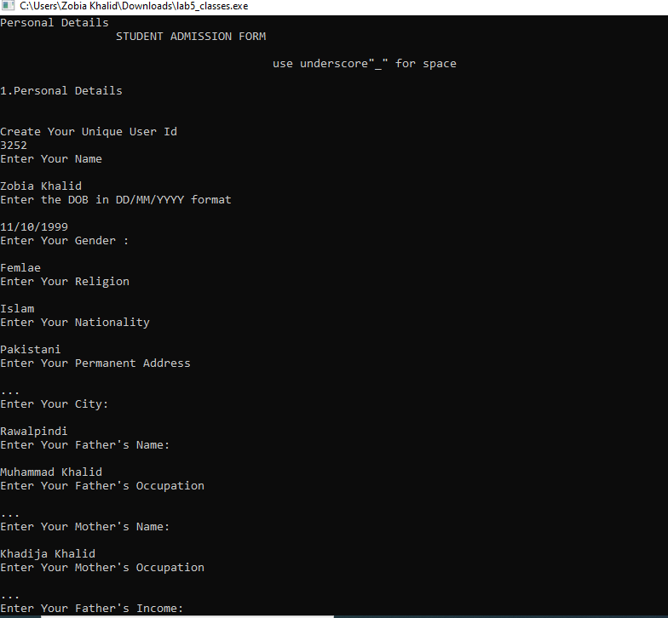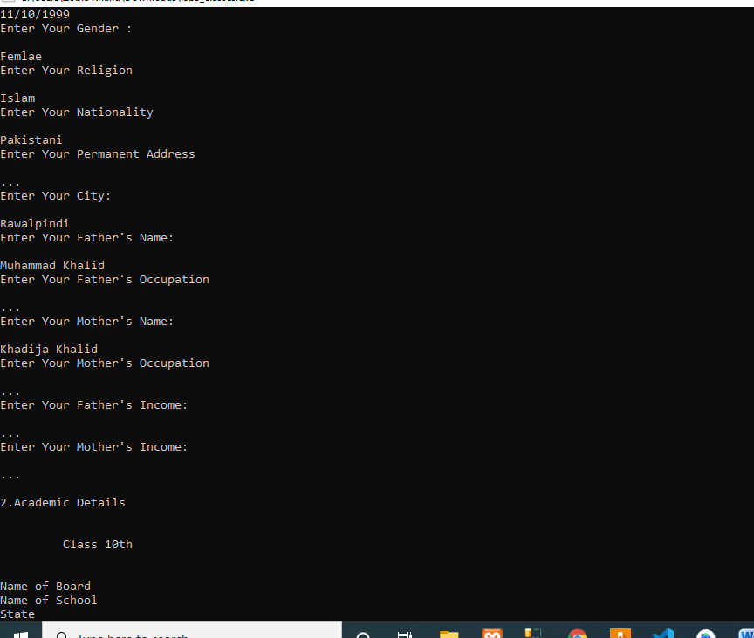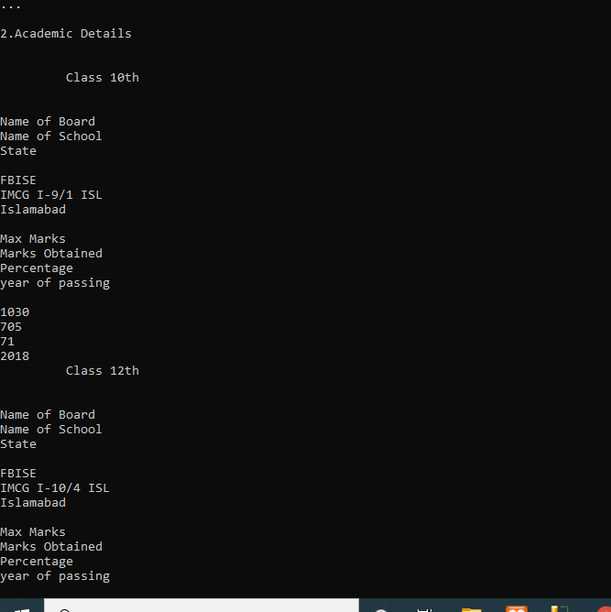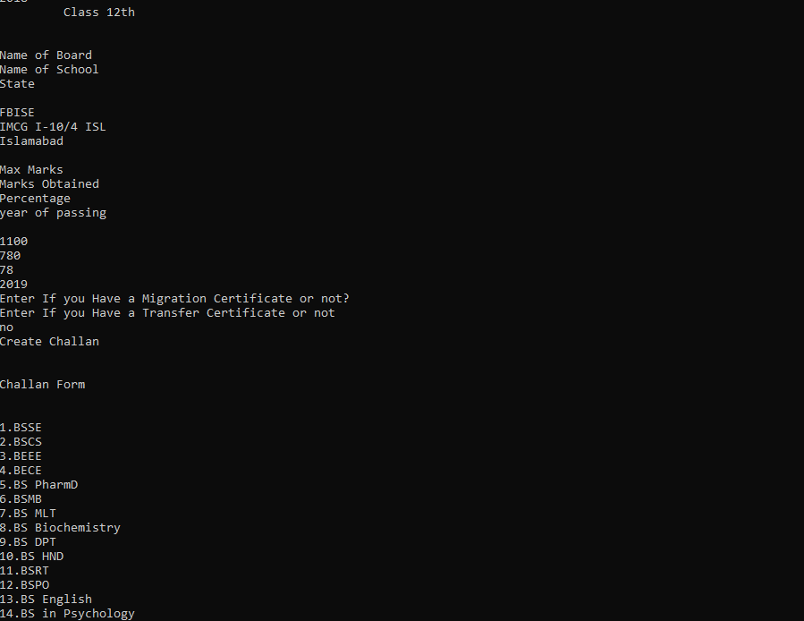

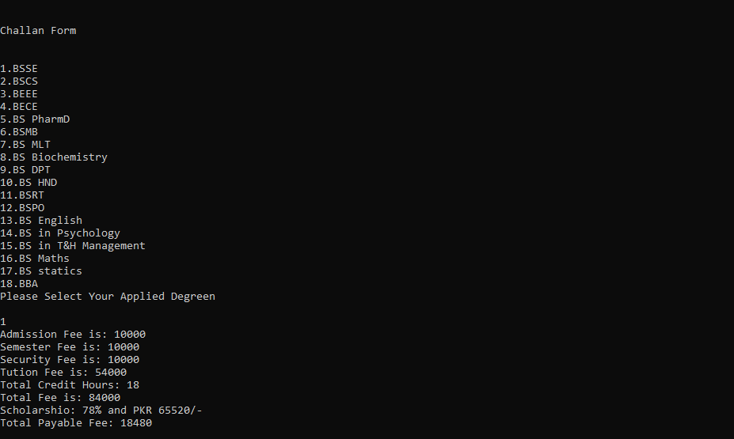

**Chain of Responsibility pattern:**

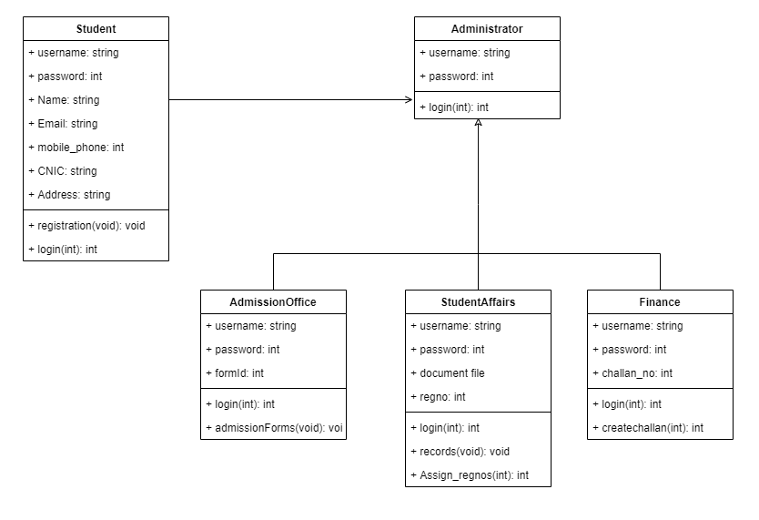

**Implementation in c++:**

COR Scenerio Created with dummy imaginary form. It is clearly described that how the COR pattern will be applied on this system and how the chain of responsibility transfer from one class to another.

**Code:**

#include <iostream>

#include <string>

#include<stdlib.h>

using namespace std;

class Student

{

public:

Student(string name) : Name(name)

{

cout<<"Enter your Full Name"<<endl;

cin>>Name;

cout << "New Student " << Name << " ...\n";

}

private:

string Name;

};

class Administator

{

public:

Administator() : mNextResponsibility(0){ }

public:

void Admision(Student &p) {

AdmisionImplementation(p);

if (mNextResponsibility != 0)

mNextResponsibility->Admision(p);

}

virtual ~Administator() { }

void setNextProcessor(Administator *p) {

mNextResponsibility = p;

}

protected:

virtual void AdmisionImplementation(Student &a) = 0;

private:

Administator *mNextResponsibility;

};

class Form : public Administator

{

public:

enum AdmisionForm { Computing, EE, CE, PharmD, LifeSciences, SocialSciences };

Form(AdmisionForm s) : AF(s) { }

private:

void AdmisionImplementation(Student &a) {

cout<<"**************************************************************"<<endl;

cout<<"\t\t\tAdmission System"<<endl;

cout << "Fill Admission Form and upload your documents\n";

}

AdmisionForm AF;

};

class AdmissionOffice : public Administator

{

private:

void AdmisionImplementation(Student &a) {

cout<<"**************************************************************"<<endl;

cout<<"\t\t\tAdmission Office"<<endl;

cout << "Got filled Admission Form\n";

}

};

class StudentAffairs : public Administator

{

private:

void AdmisionImplementation(Student &a) {

int regno=rand();

cout<<"**************************************************************"<<endl;

cout<<"\t\t\tStudent Affairs"<<endl;

cout << "Got Documents of new Student\n";

cout<<"Documents Verified \n";

cout<<"Assigned Registeration Number is "<<regno<<endl;

}

};

class Finance : public Administator

{

private:

void AdmisionImplementation(Student &a)

{

cout<<"**************************************************************"<<endl;

cout<<"\t\t\tFinance"<<endl;

int tutionfee = rand();

int credithours=6;

int Totalfee=(tutionfee*credithours)*10000;

cout << "Challan\n";

cout<<"Payable Fee: "<<Totalfee<<endl;

cout<<" Tution Fee: "<<tutionfee<<endl;

cout<<" Credit hours: "<<credithours<<endl;

}

};

void admissionhandle(Student &admission)

{

Finance f;

AdmissionOffice AO;

StudentAffairs SA;

Form fm(Form::Computing);

fm.setNextProcessor(&AO);

AO.setNextProcessor(&SA);

SA.setNextProcessor(&f);

fm.Admision(admission);

}

int main()

{

Student *s = new Student("New Admissons");

admissionhandle(*s);

return 0;

}

**Screenshots:**

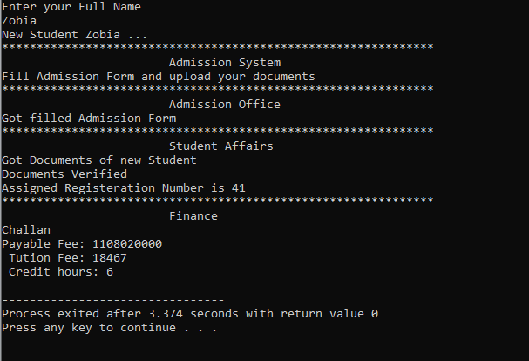

**Grasp pattern:**

1. **High cohesion**

The purpose of Administrator class is to read the registered accounts on system and it does not implement other unrelated things. Hence it is highly cohesive.

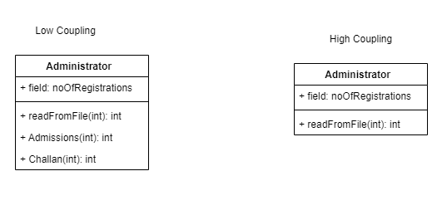

class Administrator {

// -------------- functions related to read resource

// read the resource from File only

public int readFromFile(int Registered) {

return "No registered accounts are " Registered();

}

}

1. **Low Coupling**

Here we will demonstrate how to achieve loose coupling by applying dependency injection mechanism, the loose coupling implementation is achieved to allow Get Admission with any class which has implemented AdmissionForm Class.

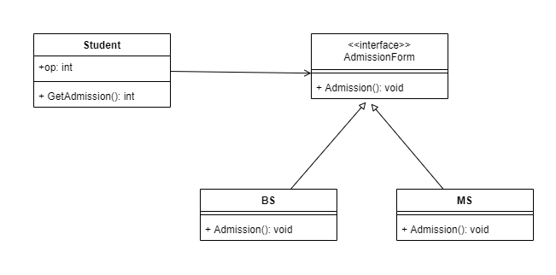

#include<iostream>

#include<stdio.h>

#include<string.h>

#include<stdlib.h>

#include<conio.h>

using namespace std;

class AdmissionForm {

public:

virtual void Admission() {}

};

class BS : public AdmissionForm {

public:

void Admission() {

cout << "Admission For BS Programs\n";

cout<<"Eligibility Critria ..."<<endl;

cout<<"Other Related formalities"<<endl;

}

};

class MS : public AdmissionForm {

public:

void Admission() {

cout << "Admission For MS Programs\n";

cout<<"Eligibility Critria ..."<<endl;

cout<<"Other Related formalities"<<endl;

}

};

class Student{

public:

AdmissionForm AF;

BS b;

MS m;

public:

int op;

int GetAdmission() {

cout<<"In BS or MS"<<endl;

cout<<"Select you Degree to Apply"<<endl;

cout<<"1. BS \n2. MS \n3. Exit\n";

cin>>op;

switch(op) {

case 1:b.Admission();

break;

case 2:m.Admission();

break;

case 3: return 0;

}

}

};

int main(){

Student st;

st. GetAdmission ();

return 0;

}

